Input Data for structural analysis

of application buried pipes in open trench condition,
calculation acc. AWWA Fiberglass Pipe Design M45 (Third edition)

Please send to:
Amiblu Holding GmbH
Sterneckstrasse 19
A-9020 Klagenfurt
T +43 463 482424
info@amiblu.com

 | Text input.
 | project
 | Text input. |  | Text input.
 | company |  | contact person
 | Text input. |  | Text input.
 | street |  | phone/Fax:
 | Text input. |  | Text input.
 | postcode |  | signature:
 | Text input. |  | Text input.
 | city |  | date/stamp

Pipe Details:

nominal diameter DN | Text input. |  | sewer pipe
 |  |  | sewer pressure pipe
pressure class PN | Text input. |  | pressure pipe
 |  |  | potable water pipe
nominal stiffness SN | Text input. |  | installation in protective water area
 |  |  | air pipe
pipe material | GRP |  | storage sewer
 |  |  | others | Text input.
 |  |  | Int. vacuum | Text input.

Native soil stiffness groups. Values of constrained Modulus, M_{sn}: acc. Fiberglass Pipe Design M45; ¹ASTM D1586

Soil class | Granular |  | Cohesive |  | Modulus | Pipe zone
 | Blow count¹ | Description | q_{u} kPa | Description | M_{sn} (MPa)
- | >50 | Very Dense | > 600 | Very hard | 138
- | 30 - 50 | Dense | 400 - 600 | Hard | 69
1 | 15 - 30 | Compact | 200 - 400 | Very stiff | 34.5
2 | 8 - 15 | Slightly compact | 100 - 200 | Stiff | 20.7
3 | 4 - 8 | Loose | 50 - 100 | Medium | 10.3
4 | 2 - 4 | Loose | 25 - 50 | Soft | 4.8
5 | 1 - 2 | Very loose | 13 - 25 | Very soft | 1.4
6 | 0 - 1 | Very, very loose | 0 - 13 | Very, very soft | 0.34

Backfill soil class classification: acc. Fiberglass Pipe Design M45; ASTM D2487

 |  |  | Backfilling
Class I | Crushed rock with < 15% sand, maximum 25% passing the 9.5 mm sieve and maximum 5 % fines²⁾
Class II | Clean, coarse-grained soils: SW, SP¹⁾, GW, GP or any soil beginning with one of these symbols with 12% or less fines²⁾
Class III | Clean, coarse-grained soils with fines: GM, GC, SM, SC or any soil beginning with one of these symbols with 12% or more fines²⁾.  Sandy or gravely fine-grained soils: CL, ML, (or CL-ML, CL/ML, ML/CL) with 30% or more retained on a nº 200 sieve.
Class IV | Fine grained soils: CL, ML, (or CL-ML, CL/ML, ML/CL) with 30% or less retained on a nº 200 sieve

Proctor density for backfill | Text input. | %
(Proctor density 85 – 100 %)
¹⁾ Uniform fine sand, SP, with more than 50% passing nº 100 sieve (0.15 mm) is very sensitive to moisture and is not recommended as backfill.
²⁾ % fines is the weight percentage of soil particles that pass nº 200 sieve with 0.076 mm opening.

Foundation of pipeline | On native soil
 | very hard and rocky
 | Weak soil, not stable for foundation
  Soil replacement: thickness | Text input. | m
  material | Text input.
  Proctor density D_{Pr} | Text input. | %

Loads specification :
 | Min. cover depth |  | Max. cover depth
Soil cover depth h | Text input. | m | Text input. | m
min. Ground water h_{w} above pipe invert | Text input. | m | Text input. | m
max. Ground water h_{w} above pipe invert | Text input. | m | Text input. | m

Other surface loads | Text input. | kN/m²
For pressure pipes | Short term | Text input. | bar, e.g. system test pressure; hydrostatic pressure, water hammer
 | Long term | Text input. | bar, e.g. operating pressure (OP), system pressure (PN, DP)
Traffic load | no traffic
Load Type | Traffic (Wheel) Load |  | Recommended minimum cover Depth (metres)
ATV LKW 12 | 40 |  |  | 0.6
ATV SLW 30 | 50 |  |  | 0.6
AASHTO HS20 | 72 |  |  | 0.8
AASHTO HS25 | 90 |  |  | 1.0
BS153 HA | 90 |  |  | 1.0
ATV SLW 60 | 100 |  |  | 1.0
MOC | 160 |  |  | 1.5
Cooper E80 Railroad |  |  |  | 3.0
 | Other loads, e.g. special vehicle (please add load scheme with axle, wheels and wheel loads):
 | Text input.

Building construction:
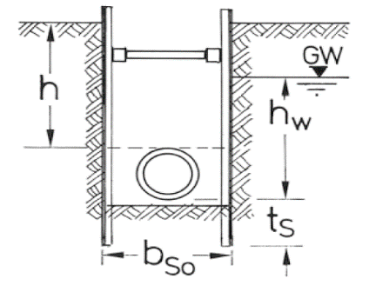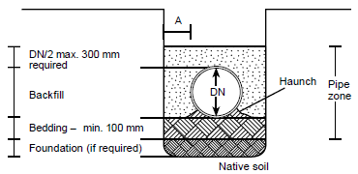

Type of trench embankment single trench double trench ¹⁾ stepped trench ¹⁾
¹⁾ For special shapes add a sketch

Text input.
Width of trench b = m at pipe springline (2xA + DN)
b_{So} = m at pipe trench bottom inclusive planks
Text input.

Typical values for A
Nominal size DN | A (mm)
DN ≤ 400 | 200
400 < DN ≤ 900 | 400
900 < DN ≤ 1600 | 500
1600 < DN ≤ 2400 | 600
2400 < DN ≤ 4000 | 900

Trench  planking no planks  Horizontal planks, also applies  to plank walls (Berlin lining)  Planking with plates  Vertical plank with light weight  Vertical plank with boards *  Vertical plank with light weight *  Vertical plank with sheet piling * | bedding on native soil (acc. EN 1610)  on gravel, sand  on concrete ²⁾  ²⁾ only as special construction in agreement with the pipe producer
* Depth of sheeting below pipe invert | t_{S} = | Text input. | m
*thickness of plank (one-side) | b_{S} = | Text input. | m

Cover condition for backfilling:

Type 1 Backfilling the pipe zone (to 300 mm) over the pipe crown with the specified backfill material compacted to the required compaction level.

Type 2 Backfill to a level of 60% of pipe diameter with the specified backfill material compacted to the required compaction level.
Backfill from 60% of diameter to 300 mm over the pipe crown with specified backfill material compacted to the required compaction level.
Not practical for small pipe diameter
Not suitable for heavy traffic loading situation

